//CS4370

//Parallel Programming for Many-Core GPUs

//Avery Colley

//Meilin Liu

//12/12/24

//Programming Assignment #2 - Tiled Matrix Multiplication

//Compiling command: nvcc Colley_Project2.cu -o matrix

Report:

The program for assignment 2 has all the functionalities required in the assignment description.

128x128 matrix with tile size = 8:

128x128 matrix with tile size = 16:

1024x1024 matrix with tile size = 8:

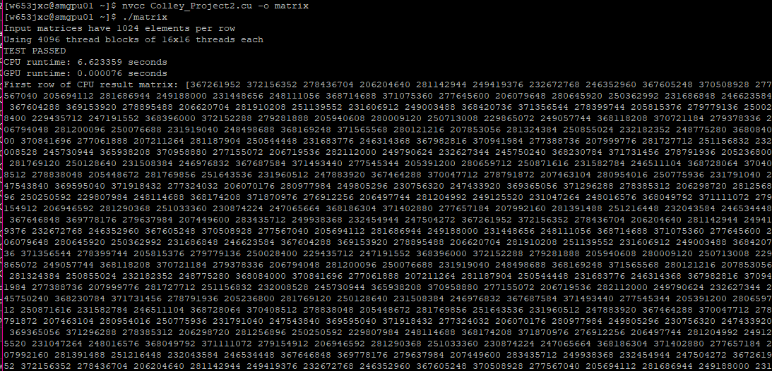

1024x1024 matrix with tile size = 16:

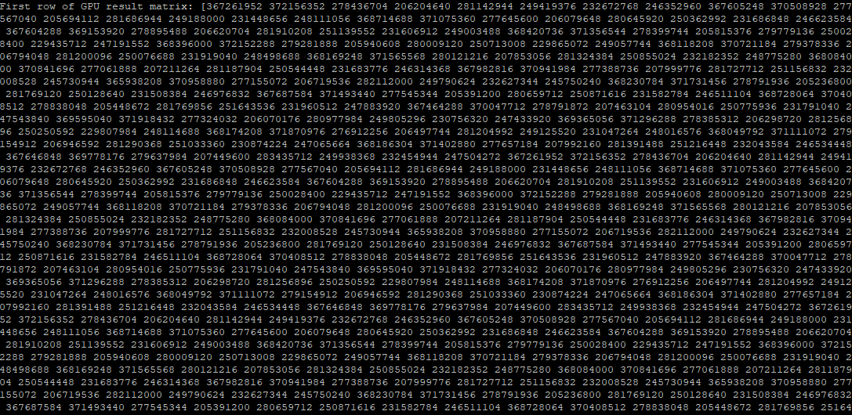

4096x4096 matrix with tile size = 8:

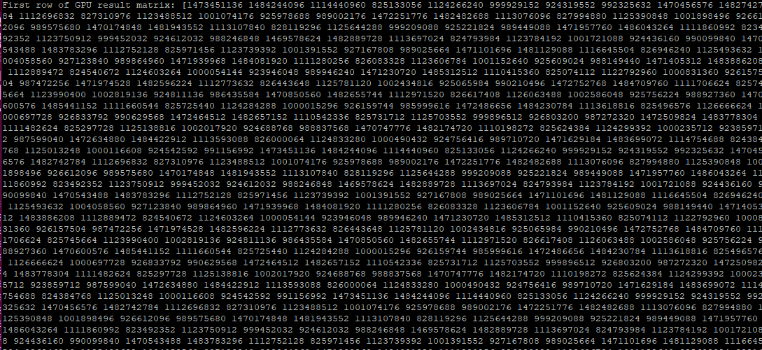

4096x4096 matrix with tile size = 16:

4096x4096 matrix with tile size = 32:

